on-line TUTORIAL
Acceptance Sampling

Discussion Questions
1. Single sampling specifies the acceptable number of defects. Double sampling means that a second sample is taken if the results
of the first sample are inconclusive (i.e., the number of defects falls
between the upper (reject limit) and the lower (accept limit)).
Sequential sampling is an extension of double sampling, with smaller samples taken sequentially until a clear decision can be made.
2. AQL (Acceptable Quality Level) is the poorest level of quality that is acceptable. LTPD (lot tolerance percent defective) is the quality level of a lot we consider bad.
3. Average outgoing quality is the percent defective of the lot shipped.
4. AOQL (Average Outgoing Quality Level) is the maximum value on the AOQ curve that corresponds to the highest average percent defective or the lowest average quality for the sampling plan.
End-of-Tutorial Problems
T2.1 | Selected Values | Mean
 | of Fraction Defective | of Poisson | P(x ≤ 2)
 | 0.01 | 0.8 | 0.953
 | 0.02 | 1.6 | 0.783
 | 0.03 | 2.4 | 0.570
 | 0.04 | 3.2 | 0.380
 | 0.05 | 4.0 | 0.238
 | 0.06 | 4.8 | 0.143
 | 0.07 | 5.6 | 0.082
 | 0.08 | 6.4 | 0.046
 | 0.09 | 7.2 | 0.025
 | 0.10 | 8.0 | 0.014

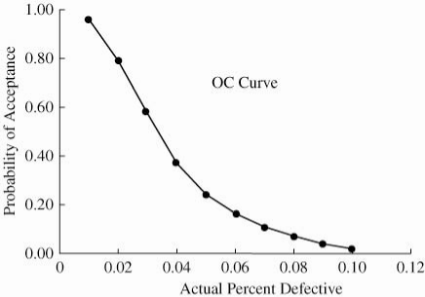

T2.2 | Selected Values | Mean
 | of Fraction Defective | of Poisson | P(x ≤ 1)
 | 0.01 | 0.05 | 0.999
 | 0.05 | 0.25 | 0.974
 | 0.10 | 0.50 | 0.910
 | 0.15 | 0.75 | 0.827
 | 0.20 | 1.00 | 0.736
 | 0.30 | 1.50 | 0.558
 | 0.40 | 2.00 | 0.406
 | 0.60 | 3.00 | 0.199
 | 0.80 | 4.00 | 0.092
 | 1.00 | 5.00 | 0.040

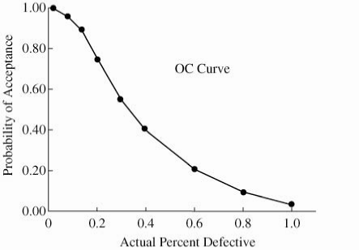
T2.3 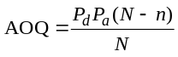
Selected Values
of Fraction
Defective | P(x ≤ 1) | (N – n)/N | AOQ
0.01 | 0.999 | 0.975 | 0.0097
0.05 | 0.974 | 0.975 | 0.0475
0.10 | 0.910 | 0.975 | 0.0887
0.15 | 0.827 | 0.975 | 0.1209
0.20 | 0.736 | 0.975 | 0.1441
0.30 | 0.558 | 0.975 | 0.1632
0.40 | 0.406 | 0.975 | 0.1583
0.60 | 0.199 | 0.975 | 0.1164
0.80 | 0.092 | 0.975 | 0.0718
1.00 | 0.040 | 0.975 | 0.0390

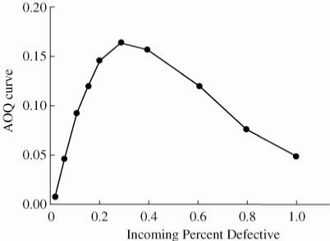

No—the plan meets neither the producer’s nor consumer’s
requirement.
T2.4 | Selected Values | Mean
 | of Fraction Defective | of Poisson | P(x ≤ 2)
 | 0.01 | 1.0 | 0.920
 | 0.02 | 2.0 | 0.677 | 1 – α at AQL
 | 0.03 | 3.0 | 0.423
 | 0.04 | 4.0 | 0.238
 | 0.05 | 5.0 | 0.125 | β at LTPD
 | 0.06 | 6.0 | 0.062
 | 0.07 | 7.0 | 0.030
 | 0.08 | 8.0 | 0.014
 | 0.09 | 9.0 | 0.006
 | 0.10 | 10.0 | 0.003

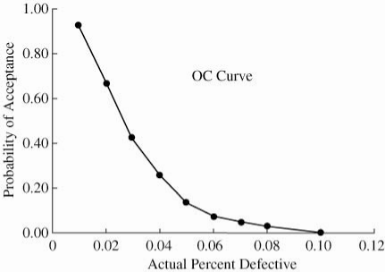
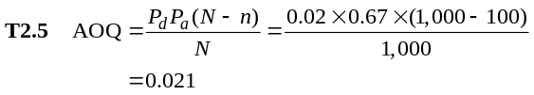
Average outgoing quality is approximately 1.2%.

